**IFT 466 Advanced Computer Networks**

**Lab 22  
STP: Find the blocking port**

**After you complete each step, put a ‘√’ or ‘x’ in the completed box**

**Objectives**

Understand how STP calculates the blocking port

1. Before you setup the following topology in packet tracker, we want turn off the link light indicators in packet tracer. If we leave these indicators on, then we will see which port is being blocked. We will turn back on these indicators to prove we have correctly identifies the blocked port.

Go to Options → Preferences → Uncheck ‘Show Link Lights’



✓

1. Now that link light indicators have been turned off, go ahead and setup the following topology in packet tracker. I just used the Cisco Catalyst 2960 switch.

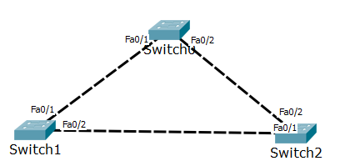



✓

1. We want to find out which switch is the root bridge and which switches are non-root bridges. We will first find the MAC address of each switch. There are many ways to find MAC address of a switch.

One way is just to hover the mouse of the switch and read off the MAC address. The MAC address of the switch is MAC address of Vlan1. In this example, I have outline the MAC address with a red box.

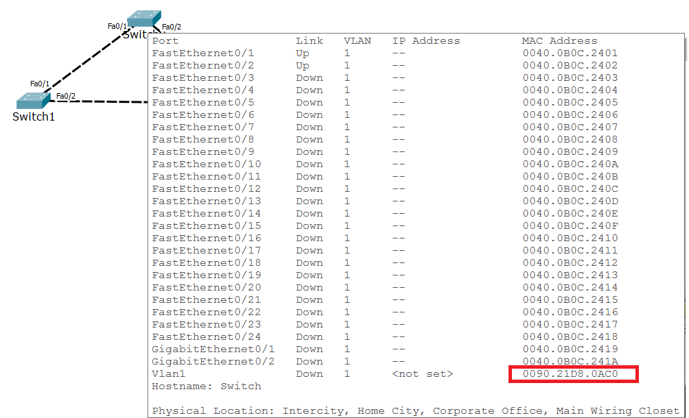

Another way to find the MAC address is to use the show version command

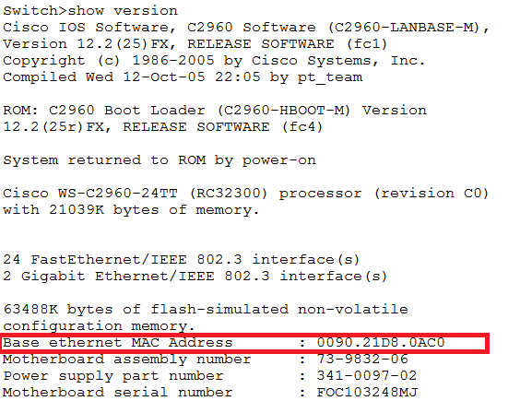

Now find the MAC address of the 3 switches in your topology and add them to the topology as show below

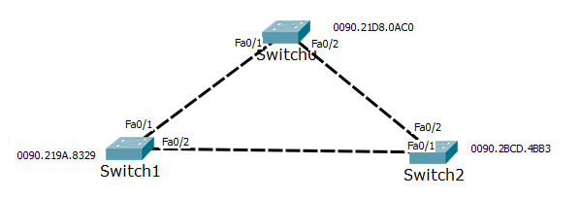



✓

1. In spanning tree, the priority value (32769) is common for all Cisco switches so we only use the value of the switch MAC addresses to determine which switch will act as the root bridge. We are looking for the switch with the lowest value MAC address. By checking the MAC address values of our switches, we see that Switch 1 has the lowest value and will be the root bridge.

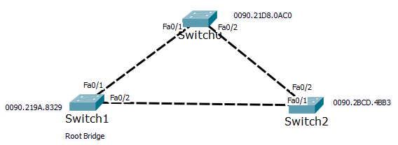



✓

1. As we have determined that Switch 1 is the root bridge, then its connected ports are designated ports.

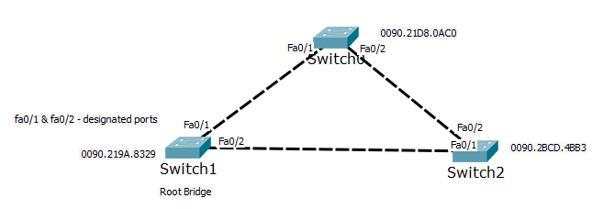



✓

1. Now we can go ahead and find out the root ports, non-designated ports and the blocking port.

Switch 0 can be connected to the root bridge i.e. Fa0/1 is the root port. If the switch can be connected to the root bridge then that port is the root port. Same for Switch 2 with Fa0/1 acting as the root port.

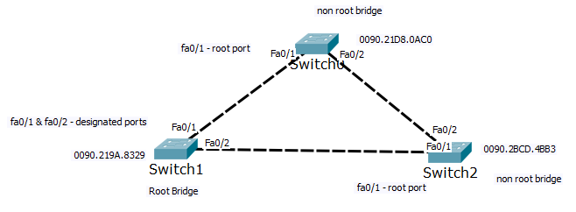



✓

1. That leaves it with both Fa0/2 ports on Switch 0 and Switch 2, either of these ports can be in blocking state.

Which one of the two ports is in blocking state? How do you find out which port is in blocking state?

The MAC address of Switch 0 can be compared to the MAC address of Switch 2 and see that the MAC address of Switch 0 has a lower value and thus Switch 0’s Fa0/2 is a designated port.

That means that the Fa0/2 port on Switch 2 is in blocking state.

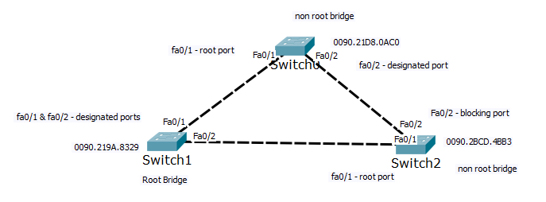



✓

1. Now we can check to see if have worked out the correct blocking port. On Switch 1, we use the show spanning-tree command. As highlighted, the switch is the root bridge and both ports are designated ports.

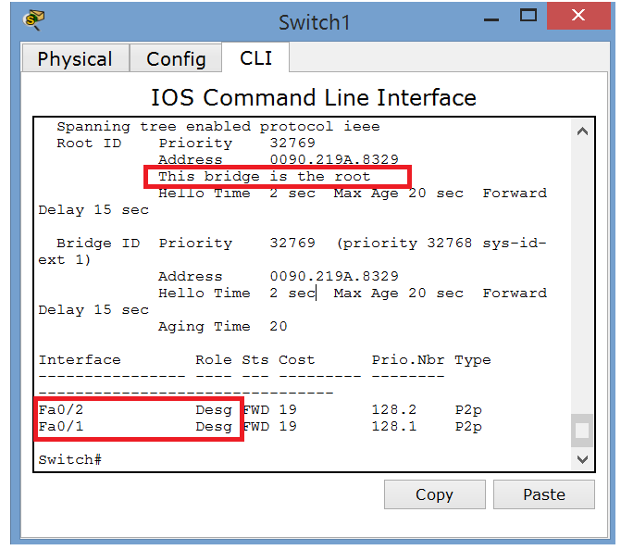



✓

1. Now run same command on Switch 0 and we can see that Fa0/1 is the root port and Fa0/2 is a designated port as we concluded earlier.

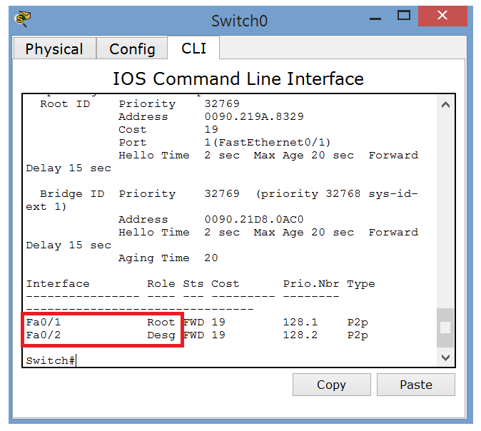



✓

1. Repeat the same command on Switch 2 and see that Fa0/1 is the root port and Fa0/2 is in alternate state → the blocking port

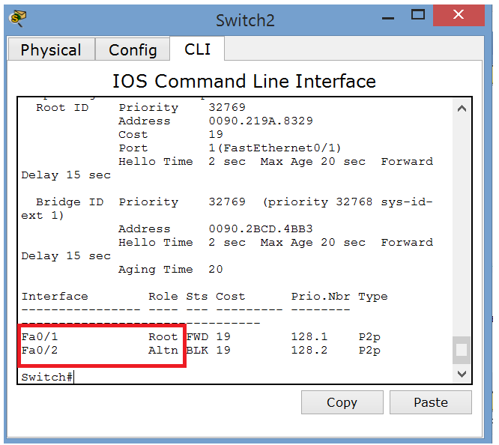



✓

1. In Cisco Catalyst Switches, STP is in-built so we do not need to configure it manually.
2. Now let’s go back and turn back on the link light indicators and you now see that the Fa0/2 port on Switch 2 (in my example) will have an orange indicator which indicates a blocking state.







